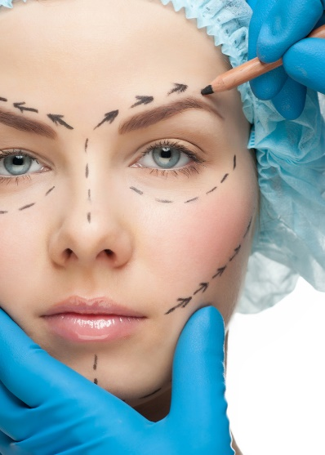
‘Nipped, Tucked, & F#%k!d’
A documentary about the physical danger and psychological damage of plastic surgery.
Image is everything! In the perfected photoshopped world of Instagram every peach is plump and it’s messing with our heads. Yes, this distorted view of the human body results real life consequences. This film will dive deep into the mass world of plastic surgery. We will follow the stories of five different people who have all had major ELECTIVE surgery, that went horribly wong. Asking these victims, why risk it?
The ideal subjects would be as follows:
A mixture of genders, possibly two women, two men, and a trans person. This variety will be further mixed up because each will have altered different and/or multiple body parts. The subjects will also be varied culturally, financially, and socially.
Prompting questions:
How long did you want to change this body part ? At what age did you realize it could be altered? When it came to finances how did you resolve it? What was your biggest obstacle before the surgery? What was your biggest obstacle after the surgery? Do you believe that social media, advertisements, and the media played a role in your decision? After surgery, how was your emotional state? Where did you find your plastic surgent? Were you excited before surgery or more scared? Were you excited after surgery or more scared? Were you prescribed opioids or pain relief medications? Were you prescribed anti-depressants? What advice would you give someone ready to go under the knife? If given the opportunity what would you do differently? What’s the next step in your recovery? Will you do it again?
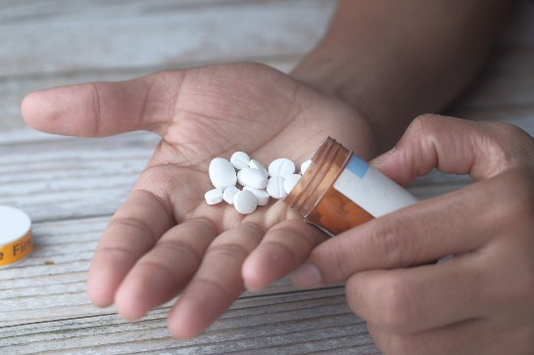
Not only will this film be intriguing, but it will also be informative it will dive into the requirements of being a plastic surgeon and certifications that aren't so official. The audience will learn the statistics and death rates of specific surgeries. They will also learn about the dark aftermath that plastic surgery clouds over its victims. Though the patients may have received the new body part they're left with a new array of issues usually from the medication prescribed.
This documentary is vital because plastic surgery is deadly. With the Accessibility of plastic surgery reaching its peaks, the awareness of danger has seemed to dim away. Breast argumentations can be made on payment plans and recovery so fast your “back at work in two weeks” (something is read on a surgeons website). But when it comes to down to it plastic surgery is nothing close to painless. I’d compare it to a serial killer cutting you open and sewing you back up. This is something our bodies simply aren't designed to do, but to heal from plastic surgery is choosing to traumatize your body. Ultimately, many are left emotionally wounded. With results not guaranteed and countless doctors receiving zero consequences for those they scar and kill, it’s time to raise the red flag.
‘Mrs. Officer’
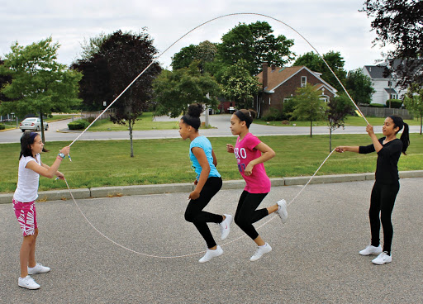
This will be a short film about two female police officers Kiesha and Nia. The film begins when Kiesha is a young girl, jumping double dutch with a group of girls. Nia, notices and wants to join in. A very spunky character she walks right over and demands the Kiesha teach her how to play. Off put by their physical differences Kiesha ignores her. Then the two get in a play-ground fight. Kiesha’s moms comes to break it up and in classic that elementary school way, the girls become close friends and inseparable by the time they reach middle school.
The ladies share a need for control and a sense of power, so, after high school they both decide the to sign up for the police academy. The two are partners and spend their days patrolling the neighborhood they grew up in. One afternoon Kiesha doesn’t show up for work and Nia knows something is horribly wrong, yet, no one is listening to her. Until, Kiesha doesn’t show up for work on Monday. Nia has to do some unique detective work to found out what happened to her best friend. She uncovers a horrific secret.
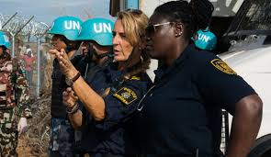
This film will dismantle certain stereotypes that are linked with specific cultures. Keisha is a Black American and Nia is Asian American. As much as black media needs to change its narrative, Asian American media is almost nonexistent. Unless the main character is a prostitute, ninja, or some sort of sexual deity, we see very little Asian leads. It’s extremely important for all Americans to see themselves represented as people not themes.
This film also centers around the importance to show women as true authority. Yes, we have tons of women protagonist and stories, but are we really being taking serious outside the realm of fantasy, as witches or queens. If the media portrays us as authority, more women would desire to hold these positions.

